0etrology for solid state lighting, Wednesday 24th April 2013
Time | Title | Speaker
08:30 | Registration, coffee & exhibition
09:15 | Welcome & meeting information | David Gibbs  Optical Measurement Group Leader
09:30 | Introduction to the European Metrology Research Programme | Dr Robin Hart,  Director of Programmes, NPL
09:45 | Metrology for Solid State Lighting EMRP project | Dr. Marijn van Veghel, VSL
10:15 | Measurement of the power factor for SSL lamps | Jean-Pierre Braun EJPD, Switzerland
10:45 | Coffee & exhibition
11:00 | Comparison report on efficacy determination of three SSL products through regular calibration services | Dr. Elena Revtova, VSL, Netherlands
11:15 | Mitigating the “Green droop” effect of Nitride LEDs | Simon Hall, NPL, UK
11:45 | Traceable spectral measurements | Armin Sperling, PTB, Germany
12:15 | Lunch & exhibition
13:30 | Mesopic Photometry for SSL | Teresa Goodman, NPL, UK
14:00 | Quality metrics for SSL characterization | Paola Lacomussi, INRIM, Italy
14:30 | SSL aging: prediction, measurement and accelerated measurement strategies | Hans Baumgartner, Aalto, Finland
15:00 | Tea & exhibition
15:30 | Human perception of SSL | Dominique Renoux, LNE, France
16:00 | Bridging the gap, the physics of InGaN LED devices | Daren Lock, Research Excellence Grant researcher, Advanced Technology Institute, University of Surrey
16:30 | Standardisation impact and current status for SSL | Giuseppe Rossi, INRIM, Italy
17:00 | Discussion
17:30-19:00 | Drinks reception and exhibition | With thanks to Philips Lighting for supporting this event
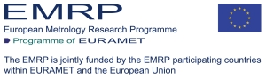
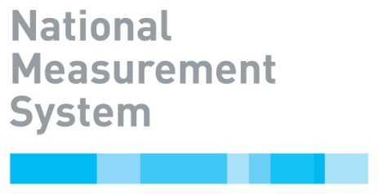
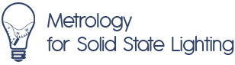
Parallel Session: Electrical Measurements, Wednesday 24th April 2013
Time | Title | Speaker
12:15 | Lunch & exhibition
13:30 | Measurement of electrical power of SSL over a wide frequency range | Torsten Lippert,  Trescal, Denmark
14:00 | Good Practice guide for traceable electrical measurements of SSL | Jean-Pierre Braun EJPD, Switzerland
14:30 | Comparison on electrical characterization of SSL and uncertainty analysis | Dr. Dongsheng Zhao,  VSL, Netherlands
15:00 | Tea & exhibition
15:30 | Electrical properties of Solid State Lighting sources | Torsten Lippert,  Trescal, Denmark
16:00 | Discussion and future directions

Metrology for solid state lighting, Thursday 25th April 2013
Time | Title | Speaker
09:00 | Registration, coffee & exhibition
09:15 | Welcome | Simon Hall & Paul Miller, NPL, UK
09:20 | Measurement Network | Tiju Joseph, NPL,UK
9:30 | Measurement of Commercially Available Solid State Lighting products: UK Round Robin | Paul Miller, NPL, UK
9:55 | Relationships between junction temperature, forward voltage & spectrum in SSL | Petri Kaha, Aalto, Finland
10:20 | Coffee & exhibition
10:50 | Guideline for the calibration of near-field goniophotometers | Marco Lopez, PTB, Germany
11:15 | Methodologies for the spectral radiant flux measurements for use in greenhouses | Dr. Elena Revtova, VSL, Netherlands
11:40 | Sector Case study of LED street lighting | Marieke Beckmann, Centre for Carbon Measurement, NPL
12:05 | Lunch & exhibition
13:30 | Characterised mesopic photometer | Michaela Schuster, PTB, Germany
13:55 | The issues of measurement of optical hazard using photometers | Simon Hall, NPL, UK
14:20 | SSL colour quality | Dominique Renoux, LNE, France
14:45 | Tea & exhibition
15:15 | Guidelines for application of SSL in state of the art lighting applications | Dusan Sabol, SMU, Slovakia
15:40 | IEA 4E SSL Interlaboratory comparison and work with the accredition bodies | Michael Scholand, Operating Agent Support, IEL 4ESSL
16:05 | Impact and future opportunities for SSL measurements & discussion | Dr. Marijn van Veghel, VSL, Netherlands
16:30 | Meeting close

